Product Title : MR TEA

Promotion Statement : Cheers with you!

Vision & Mission :

If having specific images related tea :

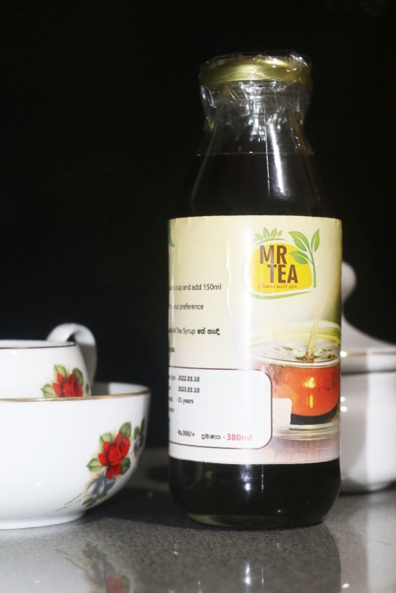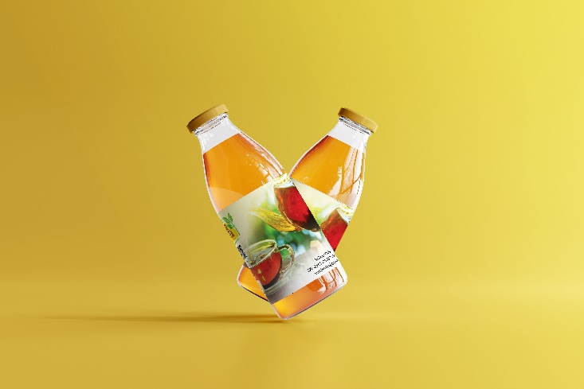**MR TEA**

A mixture of natural black tea, purified water and sugar. This offers rich flavor, strength and texture. Excellent drunk with milk.

* Flavor : Tea
* Size : 380ml
* Price : Rs.300.00

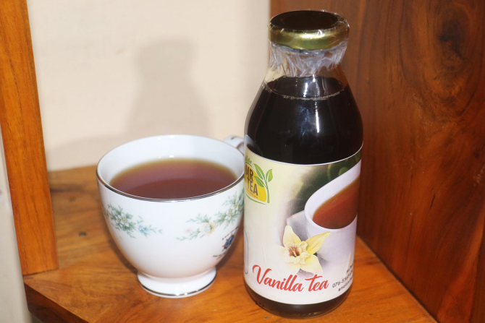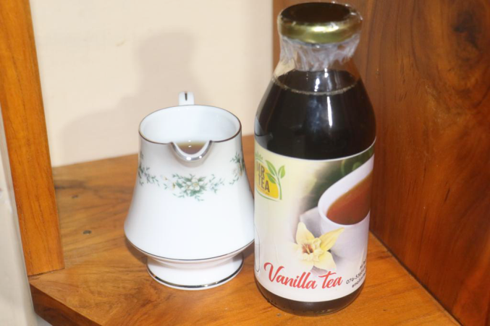**Vanilla Tea**

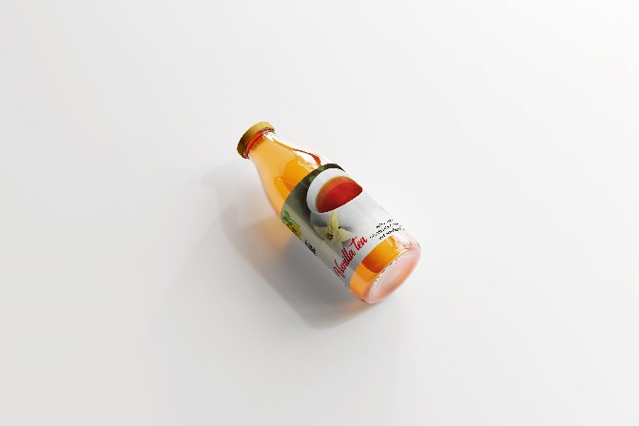

A mixture of natural black tea, purified water, sugar and vanilla. This offers rich flavor, strength and texture. Excellent drunk with milk.

* Flavor : Vanilla
* Size : 380ml
* Price : Rs.320.00

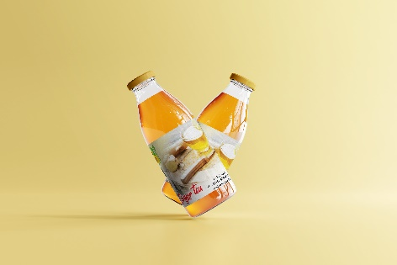**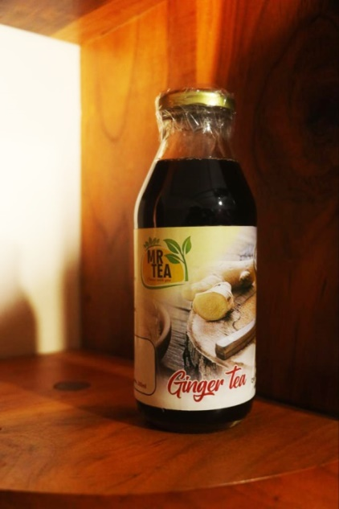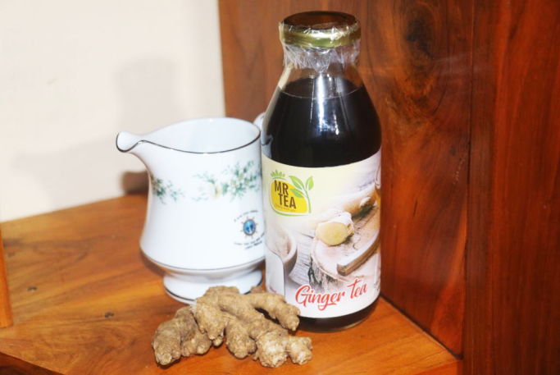Ginger Tea**

A mixture of natural black tea, purified water, sugar and vanilla. This offers rich flavor, strength and texture. Excellent drunk with milk.

* Flavor : Ginger
* Size : 380ml
* Price : Rs.320.00

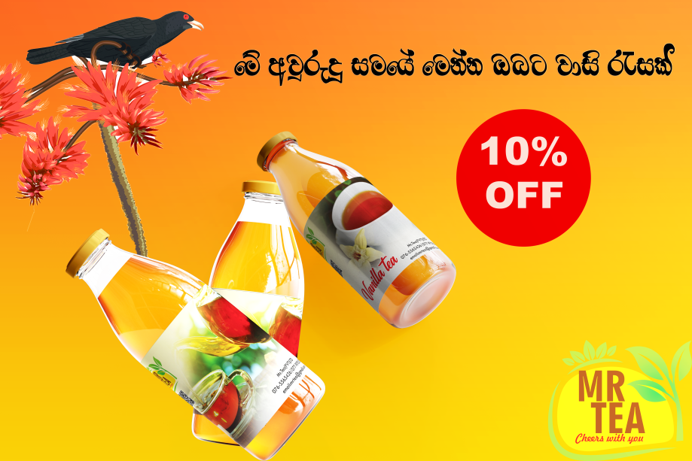If having new comer offers : 10% DISCOUNT for New Year festival

Verities of products : MR TEA

MR TEA vanilla flavor

MR TEA ginger flavor

Prices : MR TEA – Rs.300.00 (380ml)

MR TEA vanilla flavor – Rs.320.00 (380ml)

MR TEA ginger flavor – Rs.320.00 (380ml)

Address : Mr.Tea(PVT)LTD, Polgolla,

Fb page link : <https://www.facebook.com/mrtea17/>

YouTube link : <https://youtube.com/channel/UCi-t0lSUtSFM9DlYfVskWKQ>

MR TEA App link :